

**Object Oriented Programming**

**ASSIGNMENT # 3**

**Submitted by:**

**Name: Reg No:**

**Hareem Mohal SP24-BSE-133**

**Muhammad Reyan SP24-BSE-080**

**Abis Raza Haider SP24-BSE-145**

**Submitted to:**

**Sir Shahid Bhatti**

**Date:**

**13th Dec,2024**

**Section:**

**BSE-B**

**PRIMARY SCENE:**

* Contains 2 buttons login and signup
* Login checks previously entered users in the file
* Sign up for a new entry

**LOGIN PAGE:**

* 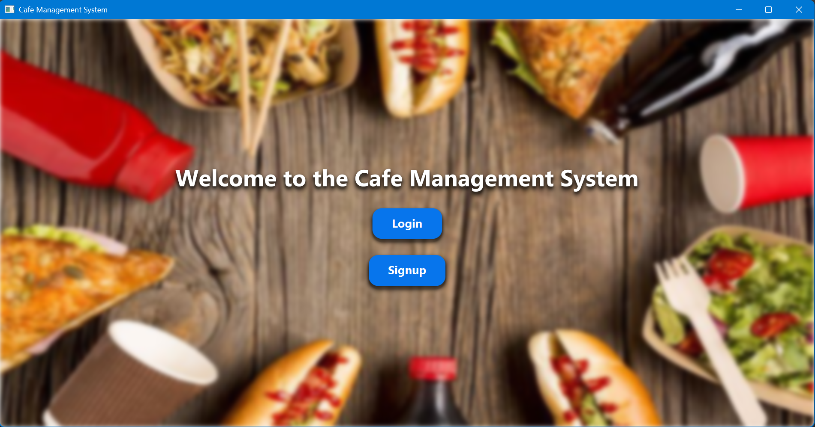Checks weather the entered info is correct or not an let’s you in.

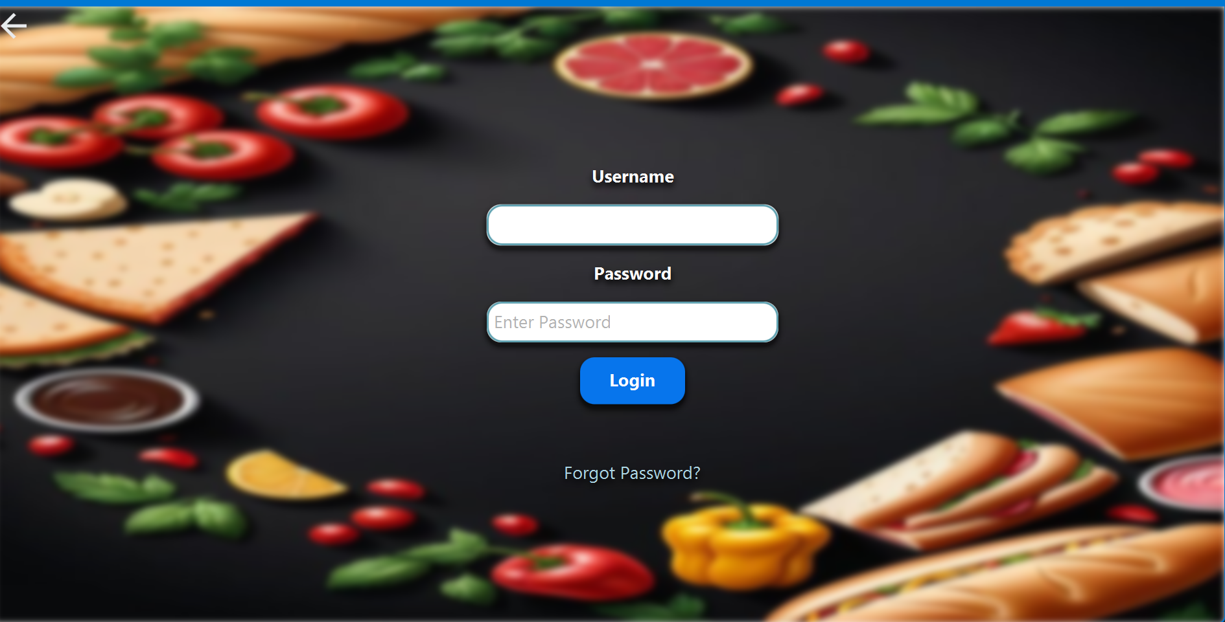

**SIGN UP INTERFACE:**

* **Registers a new user**

**MAIN SCENE:**

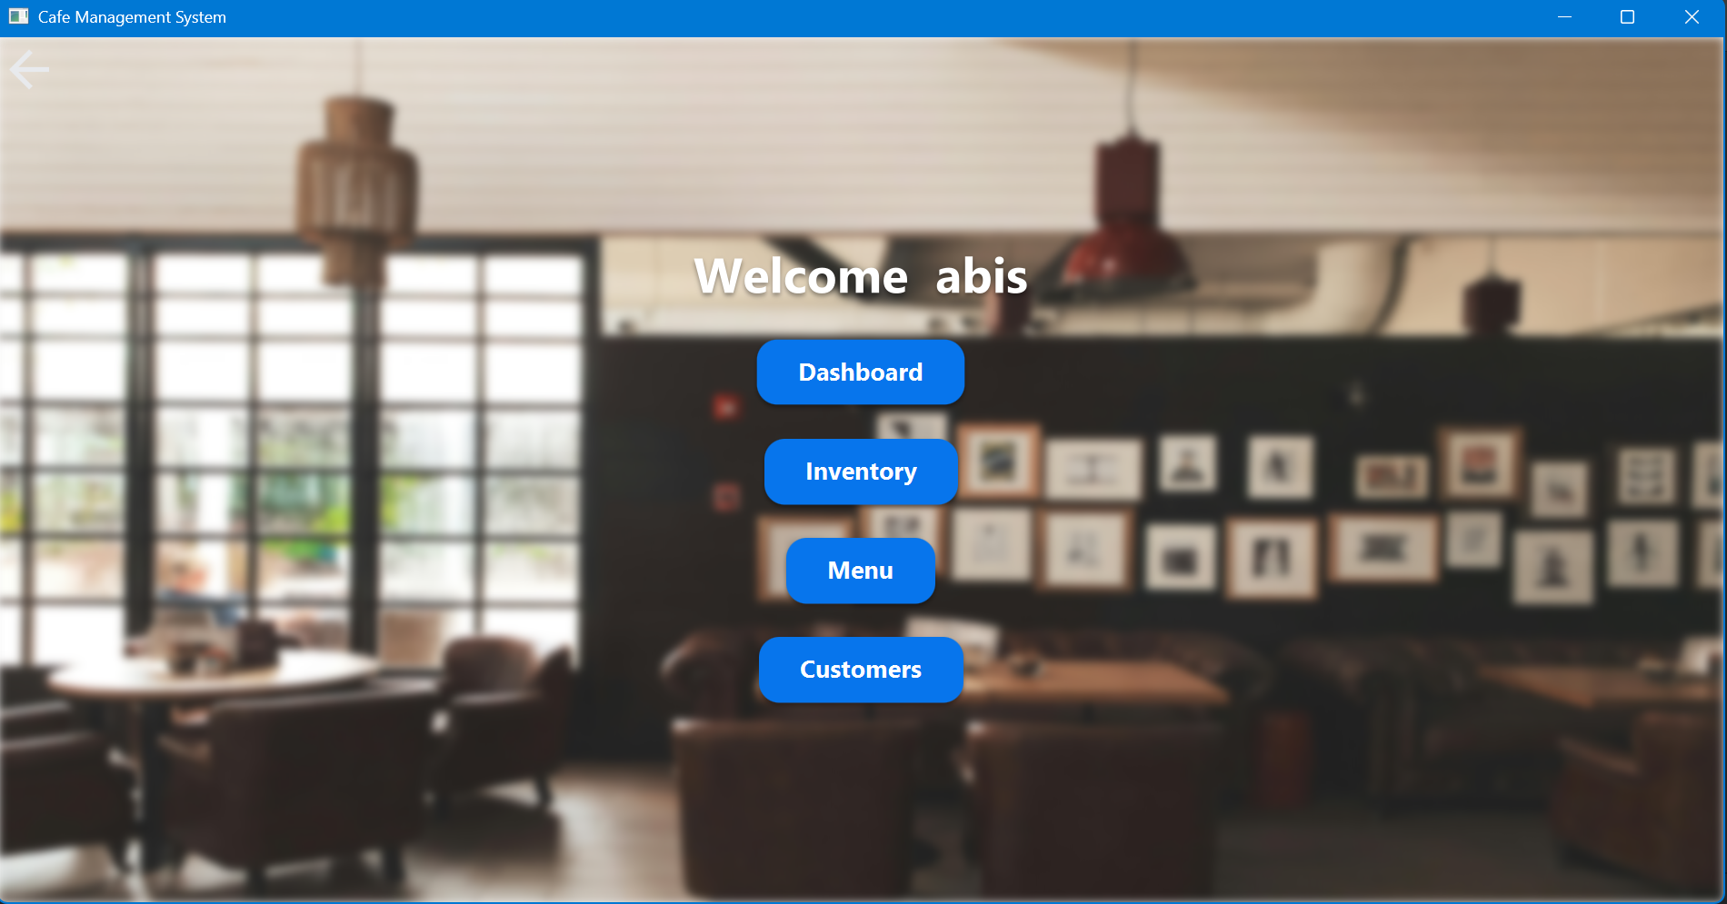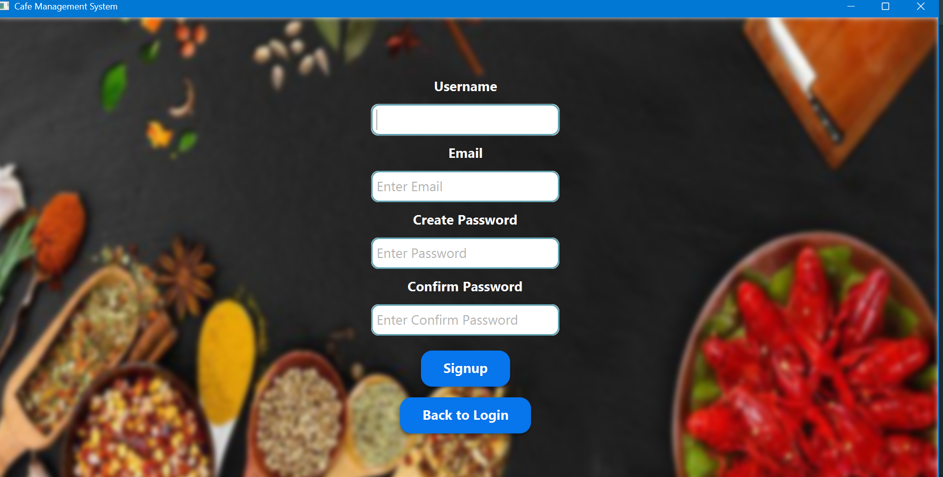

**INVENTORY:**

* Adds up product into the menu
* Deletes the product from menu
* Price can be updated

